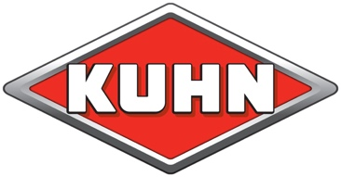
KUHN FARM MACHINERY (UK) LTD, Stafford Park 7, Telford, Shropshire, TF3 3BQ
: 01952 239300 Web: www.kuhn.co.uk

PRESS RELEASE

KUHN launches first 13m mounted tedder
KUHN Farm Machinery has launched an innovative 13m mounted tedder which will allow farmers to access hard to reach fields with a wider working width machine thanks to a compact design.
The GF 13003 is the widest mounted tedder on the market and joins the trailed version that was launched last year. The mounted design places the weight of the tedder over the rear of the tractor, to avoid the implement slipping when working on hillsides, helping to increase accuracy and stability.
Rhodri Jenkins is KUHN’s grassland product specialist: “For users after increased output from a mounted tedder, the GF 13003 offers improved manoeuvrability and the ability reach fields through narrow lanes and gateways. The clever design means all 12 rotors fold into a 2.99m transport width and a 2.67m transport height, while the tedder features just one gearbox and two hydraulic valves for simple operation.”
To maintain forage quality and prevent losses on field margins, KUHN’s Oblique setting pivots the two outer rotors rearwards when tedding on headlands, to ensure all tedded grass is thrown back on to the cut area. The system requires no additional hydraulic supply.
Uprated arms and heavy-duty tines accompany a new OPTITEDD rotor to improve longevity of the GF 13003 and reduce servicing and maintenance. KUHN suggests the asymmetrical tines are expected to last twice as long than previous tines and will improve tedding between neighbouring rotors. A reduced distance between the wheels and tines helps reduce contamination due to closer ground following.
“Further developments on the GF 13003 include rotor wheel deflectors as standard to prevent grass build-up around the wheels and column. This is especially useful in long crops and young high-sugar crops that tend to wrap around the wheels during operation,” says Rhodri.
Existing KUHN features are available, such as the Headland Lift Control which raises the two outermost rotors higher on headland turns to achieve maximum ground clearance and ensure forage is tedded only once. KUHN’s renowned DIGIDRIVE system, offering maintenance-free rotors, is also an option.
Prices start at £42,965.

-Ends-
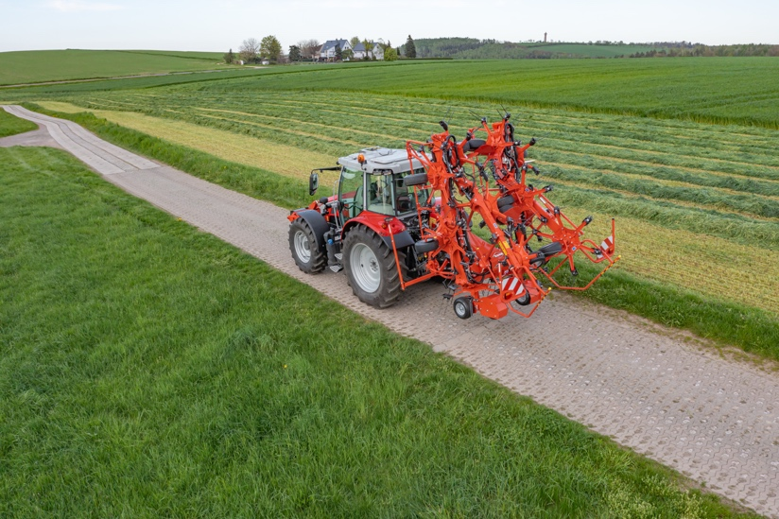
IMAGE: Folded KUHN GF 13003
CAPTION: A folding height of 2.67m and a width of 2.99m means small fields and narrow lanes are accessible
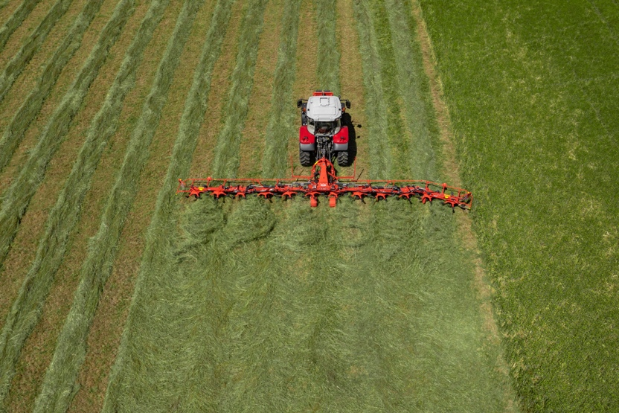
IMAGE: Oblique pivot on KUHN GF 13003
CAPTION: The two rotors pivot rearwards to avoid forage loss into uncut areas when negotiating headland passes.

29 August 2023
Notes to editors:
- The KUHN Group employs more than 5,000 people globally and has over 2,000 patents filed.
- KUHN specialises in the design and manufacture of tractor-drawn agricultural equipment: soil preparation, seeding, fertilisation, spraying, hay/silage making, baling, wrapping, residue shredding and landscape maintenance.
- KUHN Farm Machinery (UK) Ltd has its headquarters at Telford, Shropshire
- More information from Kate Hughes, Kuhn Farm Machinery (UK) Ltd, T: 01952 239300 E: kate.hughes@kuhn.com
- Issued by Agribusiness Communications Limited: Tel. 01694 731777
- This news release and image(s) can be downloaded from the ABC press centre: www.abccomms.co.uk, or by contacting sarah@abccomms.co.uk

